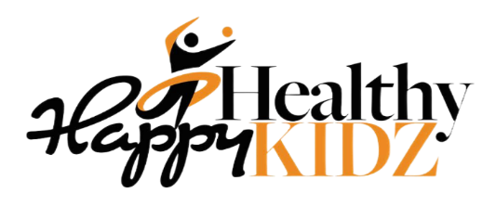
HAF (Holiday Activities and Food) Programme Summer 2022

Dear Parent/Guardian,

Happy Healthy Kidz are delighted to be delivering a FREE Holiday course during the Summer Holidays for children who are eligible for benefit related Free School Meals (FSM). Our programme is inclusive to all and available to paying families for £20 per day per child.

Venue: Braithwaite Primary School, Braithwaite, Keswick, CA12 5TD Ages: 5 – 14 years
Dates/ Times: Week 1: 25th-28th July 10-2pm
Week 2: 1st-4th August 10-2pm
Week 3: 8th-11th August 10-2pm
Week 4: 15th-18th August 10-2pm

The days will consist of multi-sports activities from football coaching, tag rugby, cricket, arts and crafts, sessions that include gymnastics, dance, and where possible animal sensory experiences. The sessions will vary from week to week and the activities may differ.

We will include nutritional activities where the children will spend some time learning about the importance of a healthy lifestyle. Children who attend the course will be provided with a healthy lunch each daily, with fruit and water for snacks. Awards and certificates will be presented at the end to every course to each participant.

Our aims are that the children are more active and eat more healthily during the school holidays; take part in engaging and enriching activities which support the development of resilience, character and wellbeing along with their educational attainment; to be safe and not be socially isolated; to have greater knowledge of health and nutrition and to be more engaged with school and other local service.

It is recommended that children bring their own named drinks bottle with them, which can be taken outside when participating in the sporting activities. Along with appropriate clothing for sports activities that be worn for both indoor and outdoor activities, including a coat.

Numbers are strictly limited and will be offered on a first come first served basis. If you would like your child to take part, then please book into this via our website: www.happyhealthykidz.co.uk
Spaces are limited and fill up quickly.

All children who attend the course must have a parent/guardian sign them out after each session, coaches will not let children leave the premises unless a named person on the booking form attends for collection.

Our coaches have a fully enhanced DBS checked, hold a FA coaching qualification, have Emergency First Aid Training and Child Safeguarding Certification. All of our ‘policies’ are available on our website. If you have any questions or queries, please do not hesitate to contact me on 0345 ​835 81 46 or email: info@happyhealthykidz.co.uk

Kind Regards,
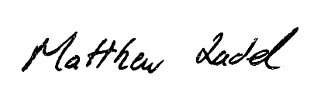@ 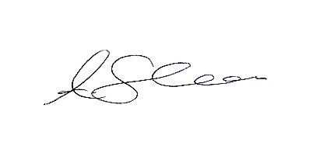
Matthew Zadel & Adam Shearer
Happy Healthy Kidz

