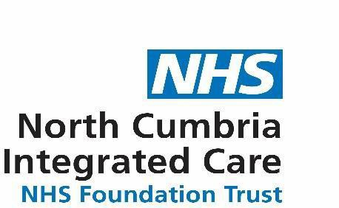
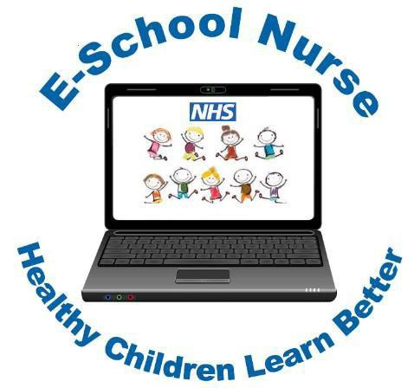

E-School Nurse Video Clinics
Weekly online health support and advice for parents, carers and professionals, supporting children and young people aged 5-19 years old.

Tuesday and Thursday

During school term time

Tuesday only during school holidays

You will be able to talk to the nurse over a live video link that is private, secure, confidential and convenient for you. In consultation with you, the nurse will assess the child or young person’s health problem and provide you with the support and advice needed.

For more information on the E-School Nurse video clinic
please read the information leaflet or visit:

www.cumbria.gov.uk/ph5to19
You can telephone for an appointment
01228 603973 (Monday - Friday 08:00-16:00)

NCIC/E-SN/Pos ter. All/012020 | APPEN D IX 03

